Professional Development Committee
2018 – 2019 Final Report

Members: Bethany Figg, Ella Hu, Stephanie Swanberg (chair), Jill Turner, Wendy Wu

Surveys to the Membership
CE Topic Survey: The committee sent out a quick survey to the MDMLG membership on September 20, 2018 seeking input on the most desired CE topics for our Spring 2019 and Fall 2019 offerings. 27 members responded to the survey with the following results ranking the four suggested topics:
- Advanced PubMed (red)
- Augmented Reality (purple)
- Multicultural Health Information (blue)
- Statistics (green)

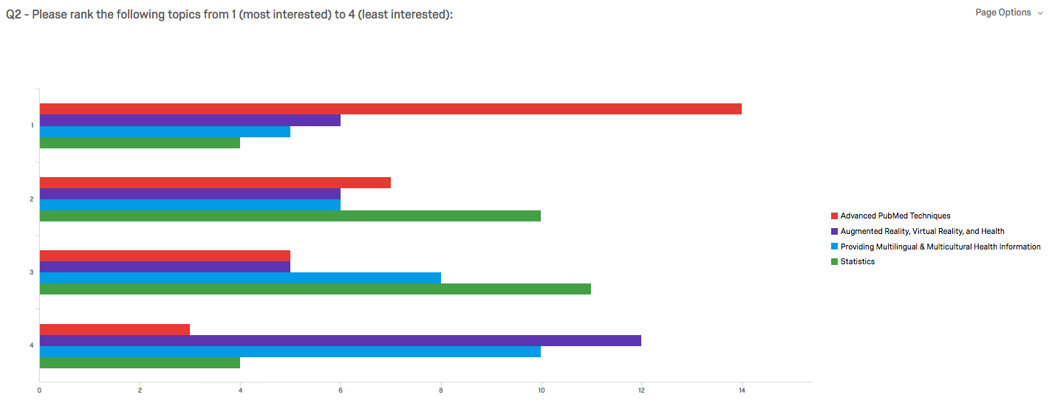

Based on these results, the committee prioritized PubMed for Spring 2019 and Statistics for Fall 2019.

2019 MLA Webinars Survey: The committee sent out a quick survey to the MDMLG membership on January 2, 2019 seeking input on the most desired MLA webinar topics for 2019. 33 members responded and, based on these results, the committee prioritized applying for GMR funding for five webinars:
- March – Take your Research Guides from Good to Great
- June (x2) – Critical Appraisal two-part series
- August – Troubleshooting Systematic Reviews – Refining the Research Question
- September – Troubleshooting Systematic Reviews – Refining the Search

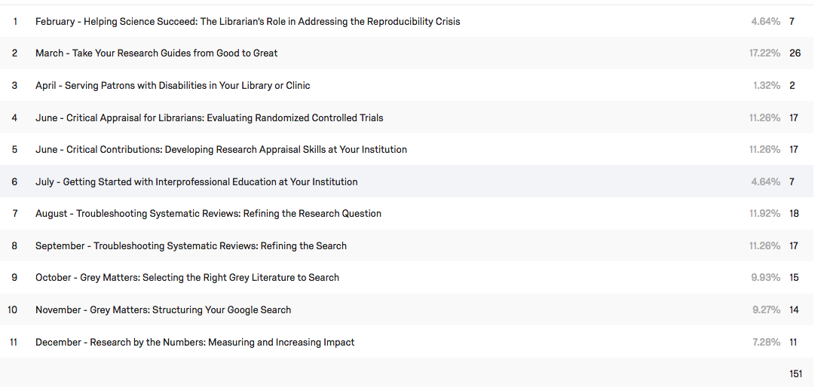
Completed Programming This Year
Webinars: We applied for and received funding from the GMR to host four webinars this year as follows:

Webinar Title | Date | Live Viewing Offered? | # Registrants | # Attendees at Physical Location | Committee Member Leader(s)
Aligning the Three Pillars of Effective Instruction | July 12, 2018 | No | 26 | -- | Jill
Putting the Quality in Qualitative: Tips for Evaluating Qualitative Research Articles | September 13, 2018 | Yes  (at Fall General Meeting) | 24 | 21 | Stephanie
Successfully Plan & Promote Library Events | October 11, 2018 | No | 18 | -- | Bethany
Take Your Research Guides from Good to Great | March 14, 2019 | No | 23 | -- | Ella

In addition, to encourage further collaborations among the regional groups and reduce redundancy in applying for GMR funding, MMHSL received GMR funding to host the January 2019 MLA webinar “From Protocol to Publication: Maximizing the Return on Your Systematic Review Investment” and opened up registration to MDMLG members.

In-Person CEs & Programming:
GMR Priorities Shift: The committee unfortunately learned at the 2018 MHSLA conference that the GMR will no longer be offering educational CEs to local or state groups (for a fee or free) as their goals are shifting to outreach. This greatly impacts our CE options as MDMLG cannot fund out-of-state speakers every year. The committee reorganized our approach and focused on tapping local librarians with expertise in our areas of interest to develop and/or pilot CEs for MDMLG.

Fall 2018 Combined General Meeting & Webinar Viewing (Committee Leaders: Stephanie – webinar; Katherine Akers & Akilah Wood from Program Committee – lunch and advertising)
- Date: Thursday, September 13, 2018; 11:30 – 3:30pm; Stapleton Conference Room, Shiffman Medical Library
- Based on the survey results from 2017 - 2018, the Professional Development and Program Committees partnered to plan and host a combined Fall General Meeting in Fall 2018. Program Committee planned the location, lunch, and advertising and Professional Development received GMR funding to host the webinar “Putting the Quality in Qualitative: Tips for Evaluating Qualitative Research Articles” which was live streamed with a short discussion following. A total of 21 participants attended the live viewing plus three who selected to watch remotely. This seems a very viable option for meetings in the future.

Spring 2019 Combined General Meeting & CE: Chemicals & Drugs in PubMed & ToxNet (Committee Leaders: Stephanie – location & speaker coordination; Bethany – advertising & registration; Katherine Akers from Program Committee – lunch)
- Date: Thursday, April 18, 2019; 10:30am – 4:00pm; Lower Level Classroom 1, Administration Building West, Beaumont Hospital Royal Oak
- MLA CE Credits: 4
- Instructor: Chana Kraus-Friedberg, Health Sciences Librarian at Michigan State University
- Attendees: 14 total attendees
  - 13 members ($35)
  - 1 student ($15)
- Recording: The CE was recorded using WebEx to create a screencast of the slides with the presenter audio. The recording was provided to all attendees following the session. The recording was also offered for the same price after the CE, but no one registered to only view the recording.

Final Expense Report: Our committee’s hard work paid off in reducing member pricing while keeping costs low as we were only $36 expenses over income this year compared to $500 last year.
Upcoming Programming for 2019 - 2020:
- MLA 2019 Webinars: The committee plans to apply for GMR funding to host the following webinars for 2019:
  - June (x2) – Critical Appraisal two-part series
  - August – Troubleshooting Systematic Reviews – Refining the Research Question
  - September – Troubleshooting Systematic Reviews – Refining the Search

- Tentative Fall General Business Meeting & Webinar Viewing (Tentatively Thursday, September 5; time & location TBD) - will feature the business meeting followed by a live viewing of the MLA September webinar “Troubleshooting Systematic Reviews – Refining the Search.” Stay tuned for more information!
- Fall 2019 CE Opportunity – Beyond Pyramids of Evidence: Evaluating Research in the Health Sciences Literature (Thursday, November 14, 2019; 1:00 – 5:00pm at University of Detroit Mercy) - Jill Turner is organizing our Fall CE course, which will feature Abraham Wheeler, Chana Kraus-Friedberg, and Carin Graves from Michigan State University and will cover interpreting many statistical analysis concepts in research studies. This course directly aligns with the top preferred topics from our CE course survey from Fall 2018. Mark your calendars now and stay tuned for more details!

Respectfully submitted,

Stephanie Swanberg
Chair, 2018 – 2019 Professional Development Committee

